ADMIN

1. First, you need to go to the homepage of Food Galore and then you can find LOGIN button at the navigation bar.

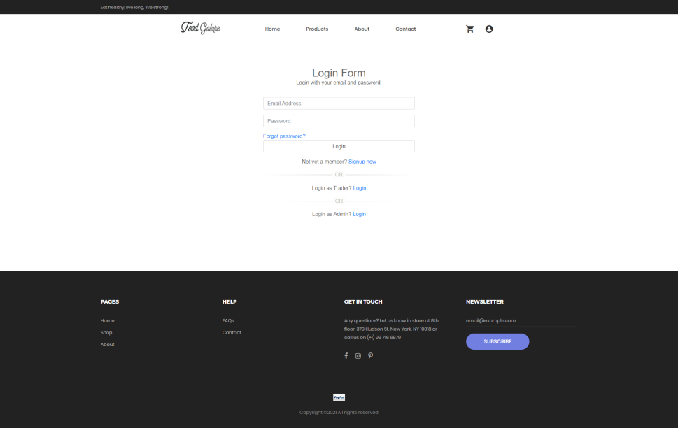

1. Click on the LOGIN button and then fill in the form with admin login credentials.

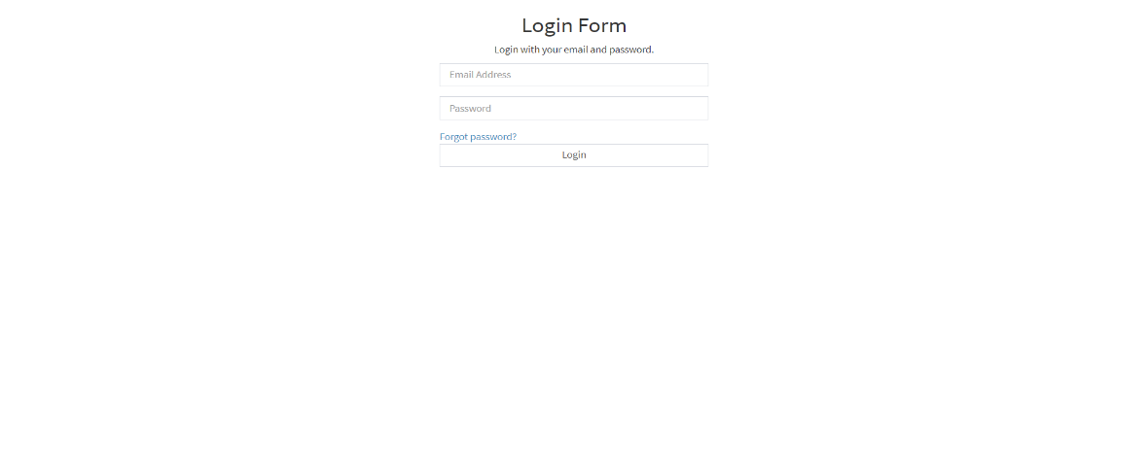

1. Once the correct admin login credentials are filled, you’ll be directed towards Dashboard. The dashboard will look like this. You’ll be able to view Monthly Sales Figure, Product Breakdown, lis of products, list of customers and list of traders.

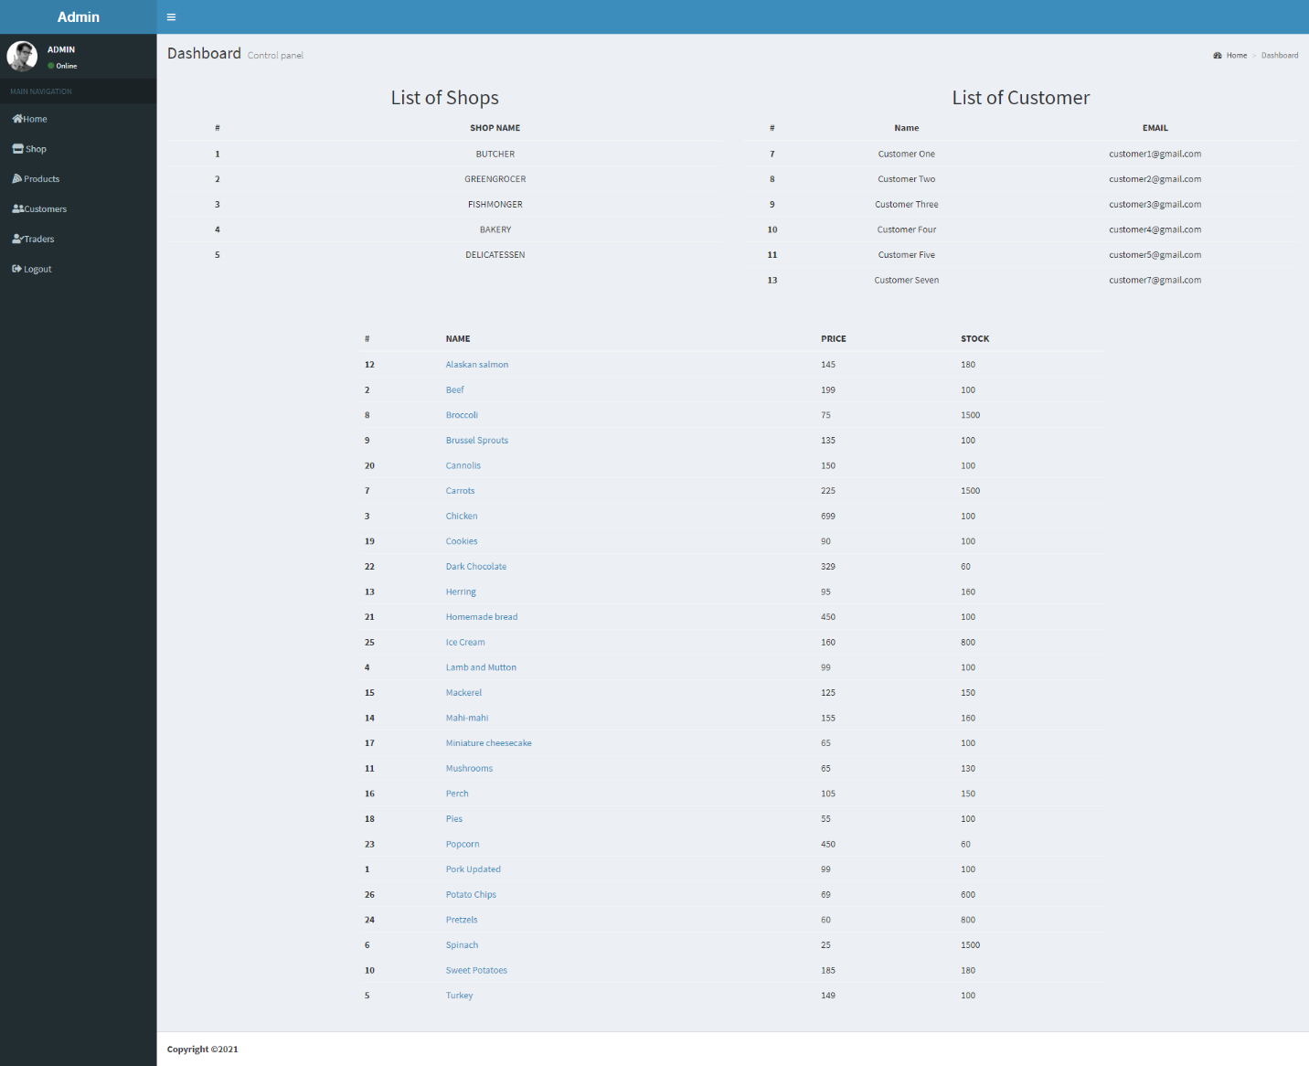

1. If you want to view individual product details then click on View Details and it will display the details of the selected product. If you wish to edit the product details click on update button. If you want to delete product then click on delete button.

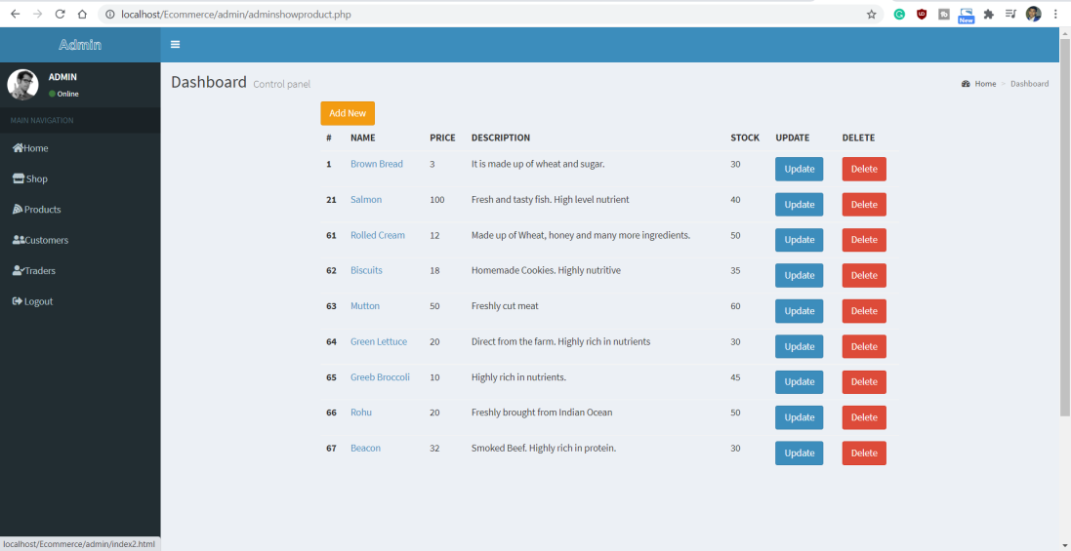

1. If you want to view all the traders then you need to click on Traders on the left side. Then it will show you the list of traders and if you wish to delete traders then click on delete button.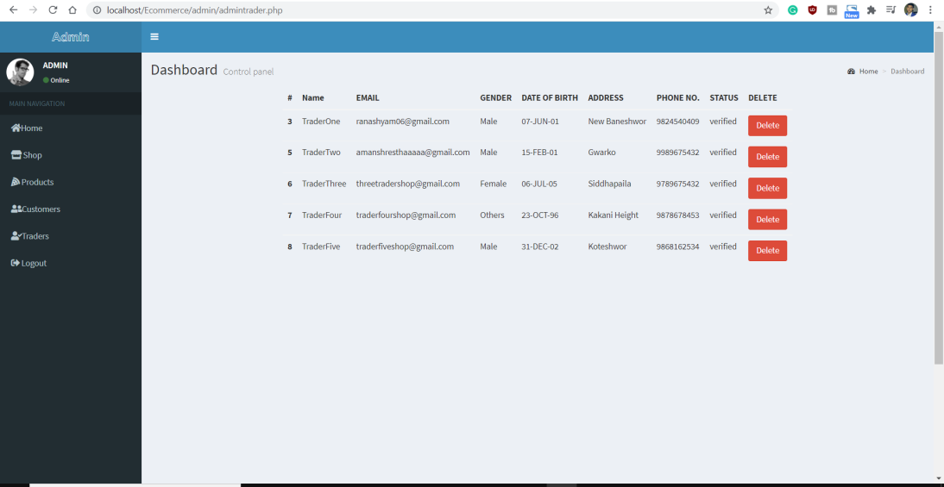
2. If you want to view all the customers then you will need to click on Customers on the left side. Then it will show you the list of customers and if you wish to delete customers then click on delete button.

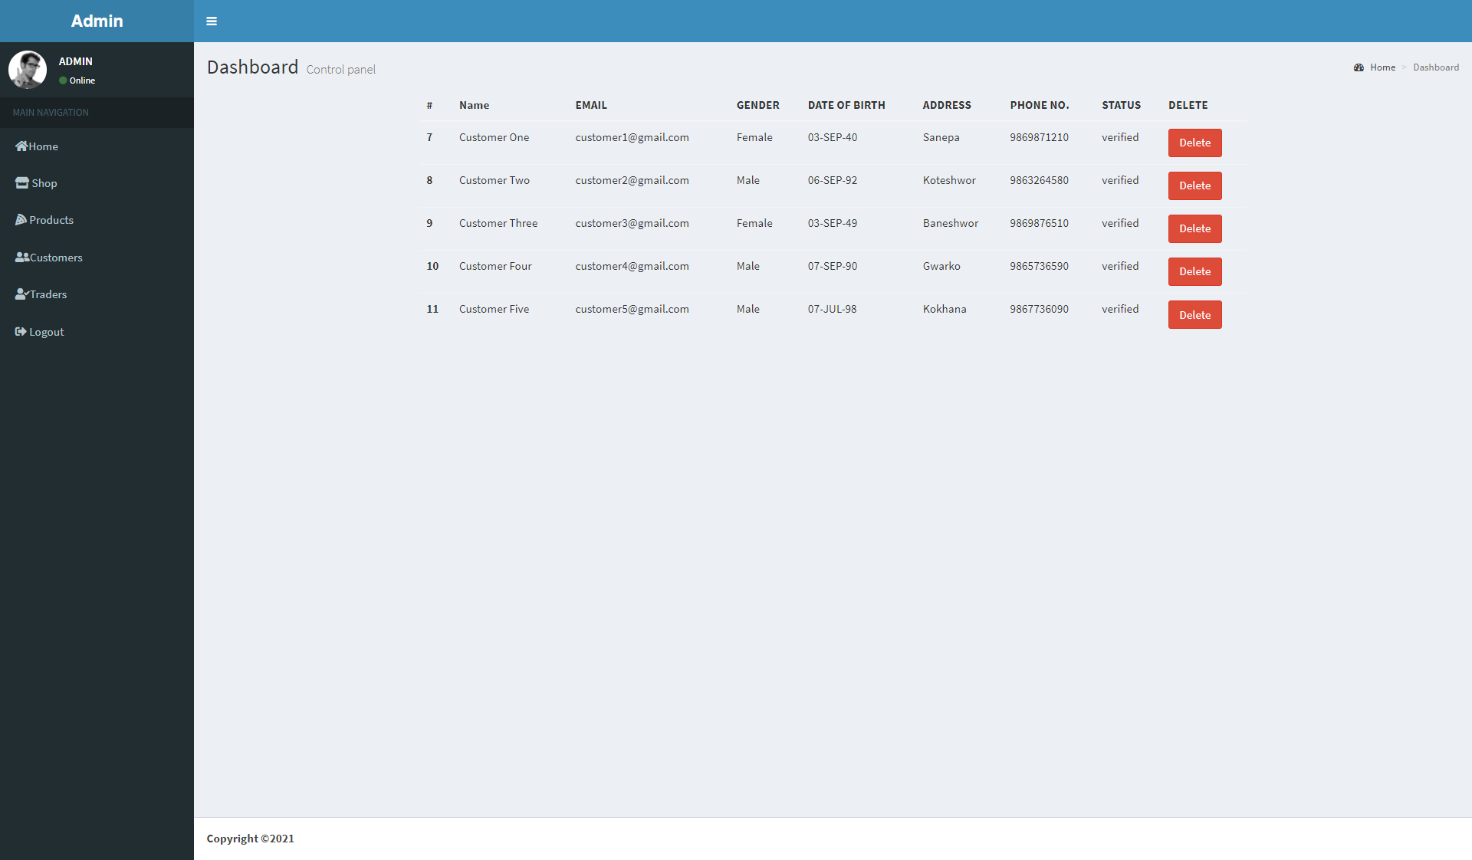

1. If you want to see all the shops that traders own then click on Shop on the left side. You can update the shop and also delete the shop. If you want to update shop, then click on update button and delete button to delete shop.

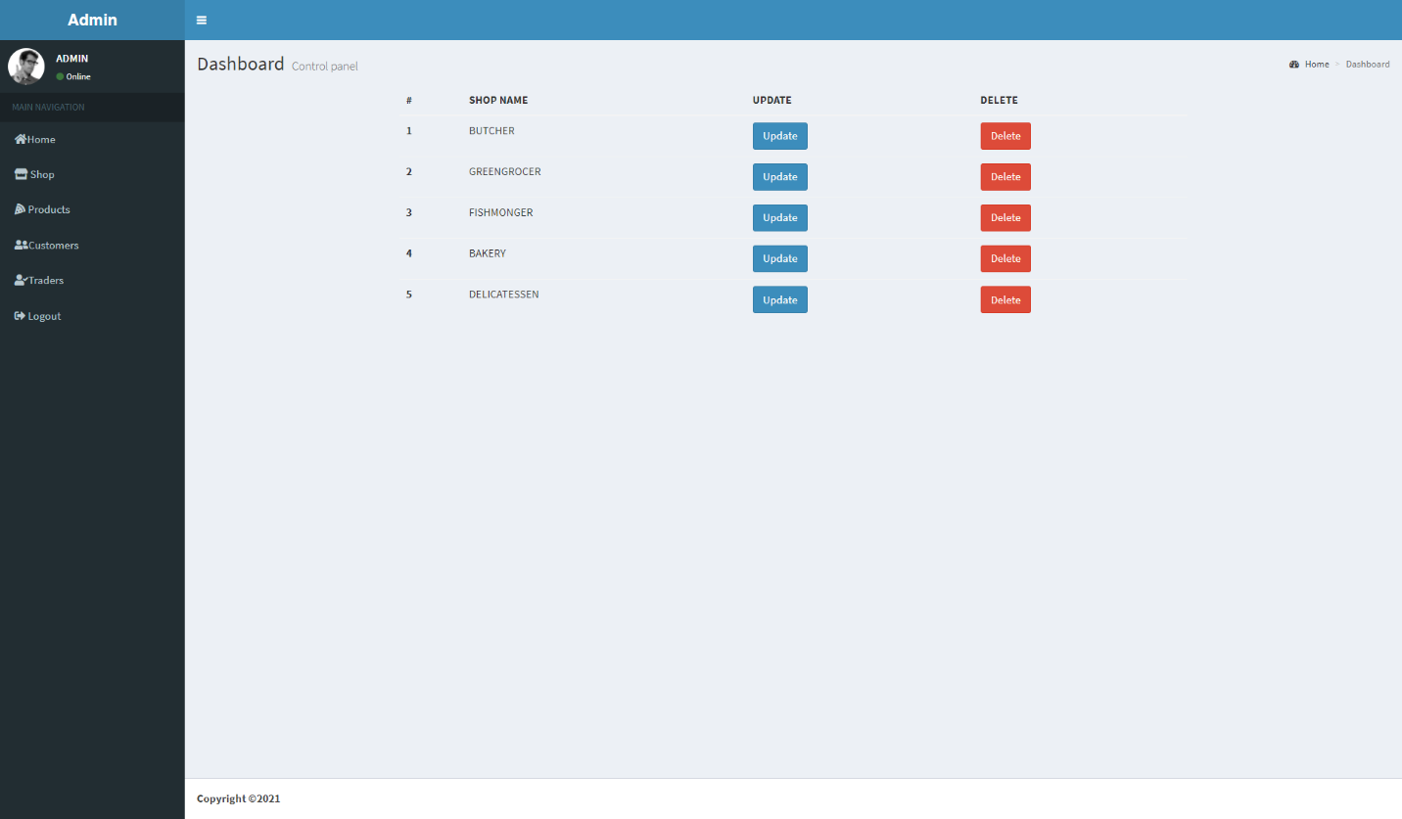

1. You can logout by clicking on Logout that is on the left side.

